Muhammad Umar Farooq
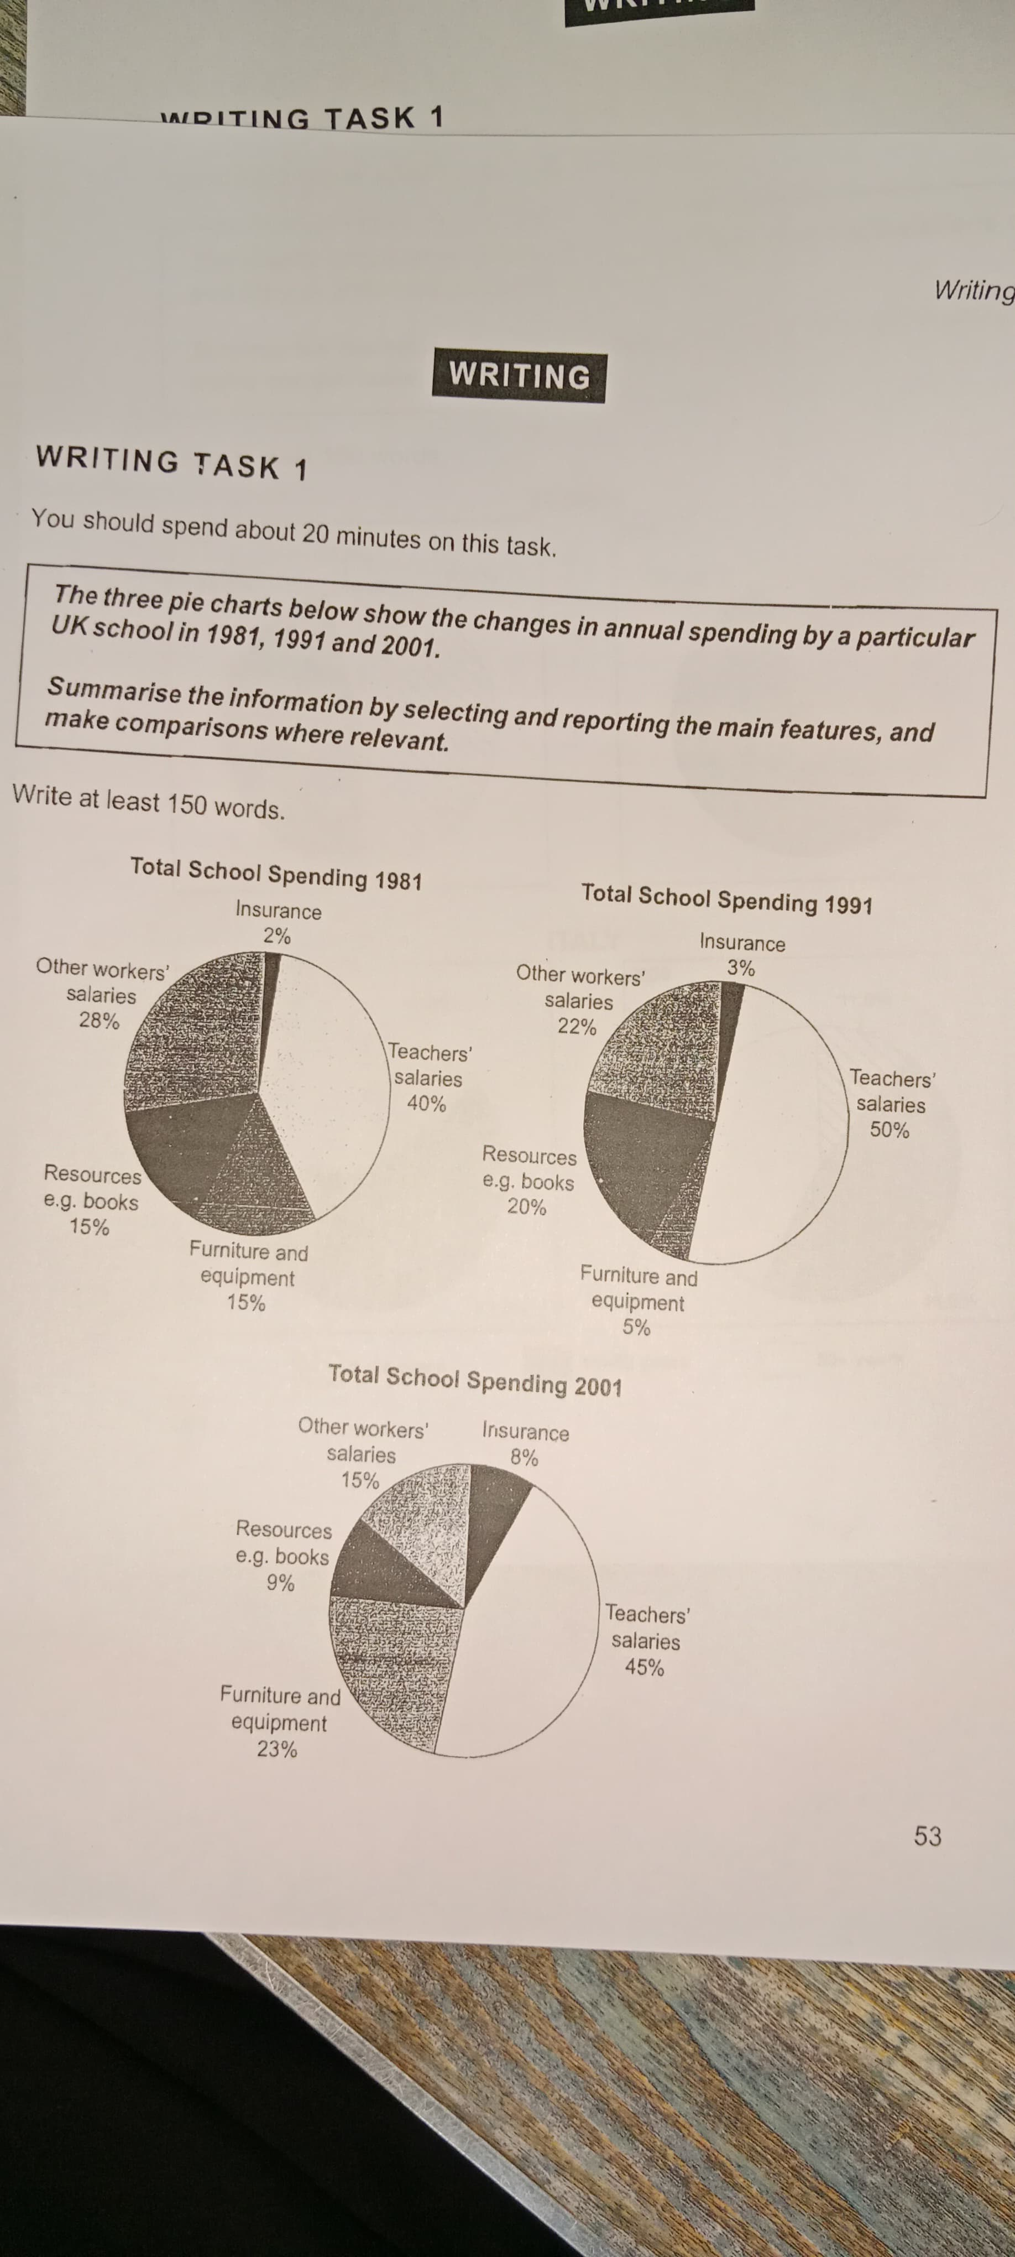
The three pie charts illustrates the modifications in yearly expenditures by the specific school in United Kingdom by 1981, 1991, and 2001.
Overall, coaching outlay had fluctuation over the period as well as this is the most costly segment overall while, other employee salaries had the downward trend, meanwhile books and other sporting resources contributing about a quarter in the budgetary allocation. Moreover, insurance, other staff salaries, and furniture collectively have about less than one third of the budget.
Looking at the details, in 1981 the 40% of the money spent on the teaching staff, and 28% of funds accommodate other staff members, collectively more than 60% of the budget consumed on the manpower. In comparison, by the 1991 training cost tuck a jump and approached at 50% while, this showed the downwards trend in a decade later in time at 45%. Furthermore, furniture contribute the significantly in budgeting and had some fluctuation between 5-23% which also include the other sportive gadgets over the time period. Academically Resources including books and study related helping material cost from 9-20% by the time spam. Lastly, insurance had the minimal consumption of the money in the total expending in the United Kingdom in three decades.

ST: 1:16
ED: 1:42

